La Casa

6385 South St

Halifax, NS

B3H 4J4

**Phone: (902)-123-4567**

**Email:** [**lacasa@gmail.com**](mailto:lacasa@gmail.com)

**Hours of Operation**

Mon:  11:30 am–11:00 pm  
Tue:  11:30 am–11:00 pm  
Wed:  11:30 am–11:00 pm  
Thu:  11:30 am–12:00 am  
Fri:  11:30 am–12:00 am  
Sat:  11:30 am–5:00 pm  
Sun:  11:30 am–5:00 pm

**Follow us on Facebook, Instagram**

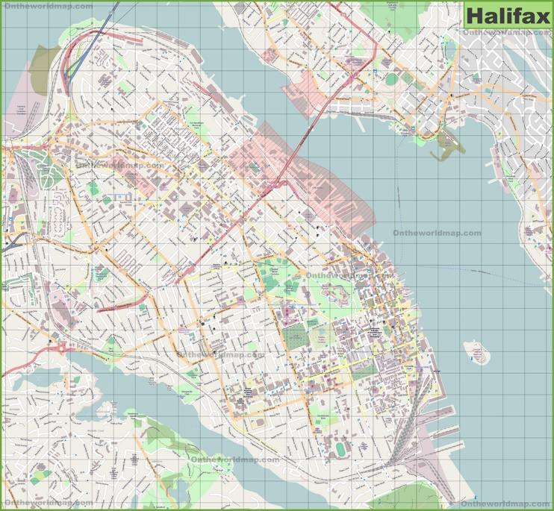

**Citation**

**Author:** ontheworldmap.com

**URL:** [**https://ontheworldmap.com/canada/city/halifax/large-detailed-map-of-halifax.html**](https://ontheworldmap.com/canada/city/halifax/large-detailed-map-           of-halifax.html)

**Date: 20th Oct 2021**